Modeling the fate of organic micropollutants in agricultural soils: Laboratory parameterization and field-scale implications
Mogens Thalmann^{1,2}*, Sondra Klitzke³, Andrea Lange^{1,4}, Aki Sebastian Ruhl^{2,5}, Andre Peters⁶
¹Institute for Geoecology, Technische Universität Braunschweig, Langer Kamp 19c, 38106, Braunschweig, Germany
²German Environment Agency, Section II 3.3, Water Treatment, Schichauweg 58, 12307, Berlin, Germany
³German Environment Agency, Section II 3.1, Protection of Drinking Water Resources, Schichauweg 58, 12307, Berlin, Germany
⁴now at: Thünen Institute of Rural Studies, Bundesallee 64, 38116 Braunschweig, Germany
⁵Technische Universität Berlin, Water Treatment, KF4, Str. des 17. Juni 135, 10623, Berlin, Germany
⁶Thünen Institute of Agricultural Technology, Bundesallee 50, 38116 Braunschweig, Germany
*corresponding author Mogens Thalmann: m.thalmann@tu-braunschweig.de
Orcid ID of corresponding author: 0009-0004-1587-1244

Supporting Information (SI)

SI for Material & Methods Section

1 Vaporization in Batch Kinetic Vessels
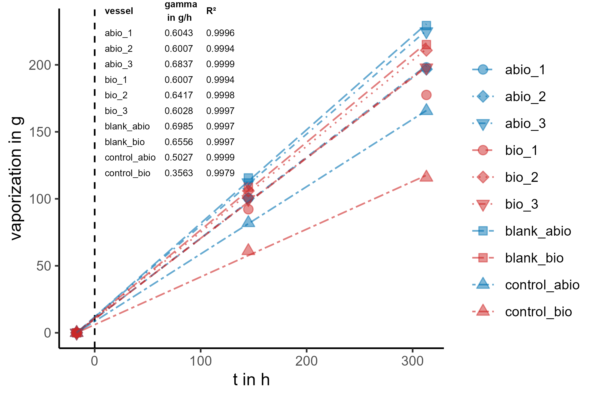
Figure S1: Vaporization in kinetic batch vessels including the zero-order fit to estimate vaporization rate γ [g h⁻¹].

2 Concomitant Parameters
pH and electrical conductivity (EC) were regularly measured in all kinetic batch samples and in isotherm experiments after 48 hours of equilibration using a hand-held meter (WTW pH 3310 and WTW Cond 3310 for pH and EC, respectively). In the kinetic batch experiments, 1.5 mL aliquots were taken at regular intervals (five times after the first spike and four times after the second spike), filtered through 0.45 µm syringe filters (regenerated cellulose, Macherey-Nagel GmbH), and analyzed for dissolved organic carbon (DOC) using a total organic carbon (TOC) analyzer (Vario TOC cube, Elementar Analysensysteme, Germany). Figure 1 presents the three concomitant parameters (pH, EC, and DOC) measured throughout the kinetic experiments (both spikes) as well as at the end of the isotherm experiment after 48 hours of equilibration (larger data points in Figure 1).
In biotic vessels, pH showed a slight decrease, whereas in soil-containing samples (“Soil” and “Blanks”), it exhibited a slight increase. This contrast can be attributed to the addition of sodium azide (NaN₃), which is known to elevate soil solution pH (Lees et al., 2018; Süßmuth et al., 2024). Moreover, the pre-equilibrated soil samples initially had a pH around 7, approximately two pH units higher than the blanks. This difference reflects the pH-elevating effect of reclaimed water (RW) compared to CaCl₂. The RW used in the kinetic experiments had a pH of 7.1 after UV treatment “Kin” in Table 3), whereas in the control samples (RW with OMP spike), the pH ranged between 7.8 and 8.6. Notably, the pH in biotic blanks closely matched the values obtained during soil characterization (Table 1). The final pH measurements at the end of the isotherm experiment were largely consistent with those recorded in the kinetic vessels.
EC exhibited a gradual increase in all kinetic batch vessels, likely due to ion concentration effects caused by evaporation (Figure S1).
In biotic samples, DOC remained relatively stable at its initial concentration throughout the experiment (Figure 1). In soil-containing samples, DOC concentrations remained around 20 mg L⁻¹, indicating that some additional DOC was released during the 17-hour pre-equilibration compared to the initial DOC concentration of 13.53 mg L⁻¹ found in the RW (“Kin” in Table 3). However, in abiotic soil samples, DOC concentrations increased substantially, rising from 20 mg L⁻¹ to approximately 40 mg L⁻¹ and 65 mg L⁻¹ in the “Soil” and “Blank” samples, respectively (Figure S1). This sharp increase is most likely associated with the adjustment to 0.2 g L⁻¹ NaN₃, suggesting that NaN₃ enhances the leaching of DOC from soil organic matter. Such an increase in DOC could reduce the sorption of organic micropollutants (OMP) to soil by competing for sorption sites on soil surface (Flores-Céspedes et al., 2006). However, the direct impact of NaN₃ on DOC leaching in soil batch experiments remains unclear as this was not examined in the current study.
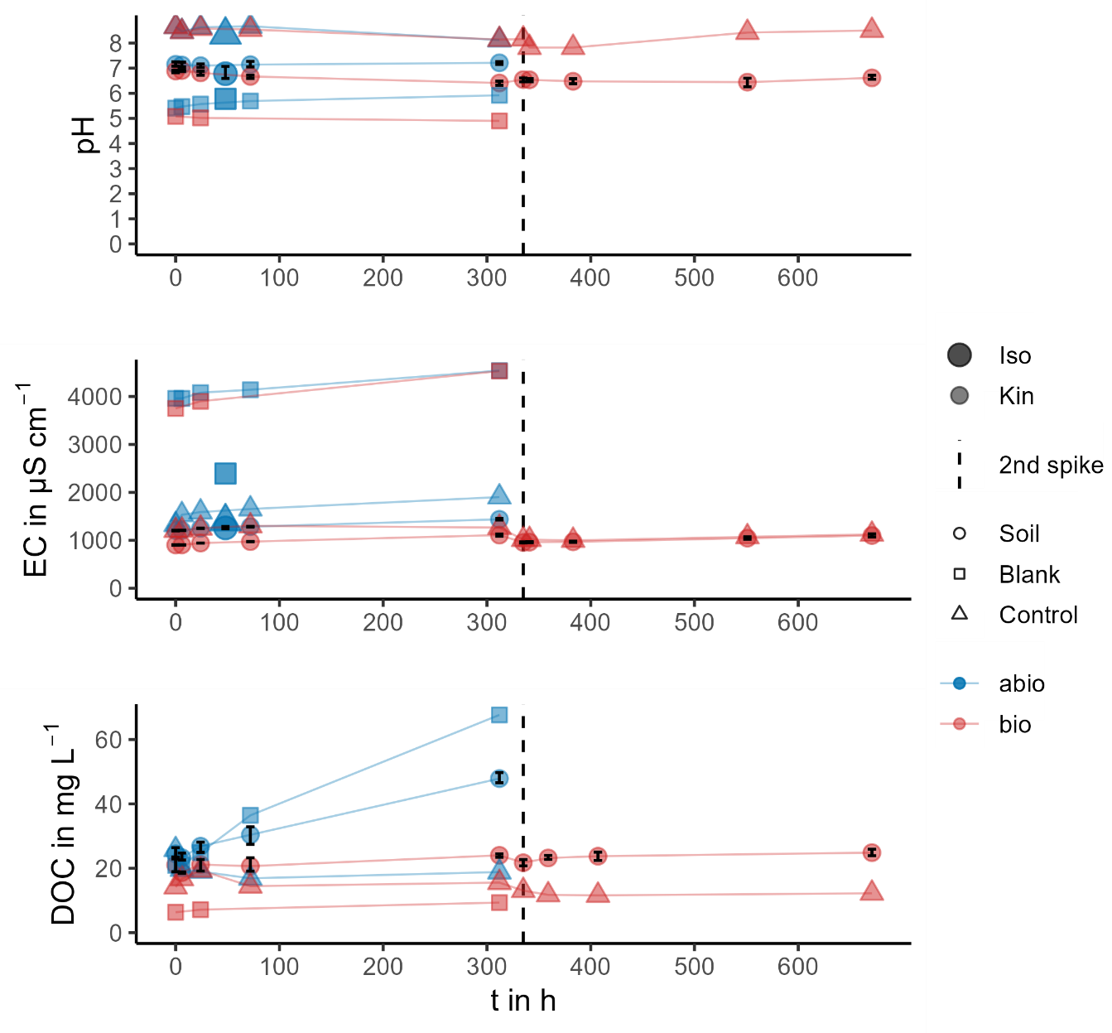
Figure S1.1: Concomitant parameters pH, electrical conductivity (EC) and dissolved organic carbon (DOC) in kinetic and isotherm experiments. Bigger points at 48 h relate to measurements at the end of the isotherm experiment (not measured for DOC). Round shaped points “Soil” are actual measurements of samples with soil and spiked RW.

SI for Field-scale Simulations using Hydrus-1D

1 Description of Hydrus-1D field-scale simulations
The field-scale solute transport simulations were conducted using the Hydrus-1D software package (version 4.17.0140; Šimůnek et al., 2013), which numerically solves the Richards equation for variably saturated water flow and the advection-dispersion equation for solute transport in one-dimensional porous media. The simulation setup adopted the modeling framework described by Thalmann et al. (under review).
The simulation spanned 51 years (2025–2075), including a one-year warm-up without solute input. OMP input was initiated with the start of RW irrigation in year the crop growth period of year two. For the current study, only the first three years after initiation of RW-irrigation were considered and evaluated to assess the specific impacts of sorption kinetics and microbial lag phases. The longitudinal dispersivity was set to 20 cm, which corresponds to one-tenth of the simulation domain length, following the commonly applied scaling relationship between dispersivity and travel distance (e.g. Vanderborght & Vereecken, 2007).

Soil Profile Discretization and Crop Rotation
A 200 cm deep soil profile was defined, divided into four layers (0–30, 30–60, 60–100, and 100–200 cm). The soil domain was divided into these four layers, to assign different biodegradation rates to different soil depths as described in the next section (S2.2). The profile was discretized using 301 nodes, with a spatial resolution of 0.5 cm in the upper half and 1.0 cm in the lower half of the soil domain. In the base configuration, free drainage condition was assigned at the lower boundary to represent deep groundwater conditions. To further test the effect of a different groundwater setting, shallow groundwater conditions were assigned by setting the lower boundary condition to constant pressure head h = 0 cm.
An annual crop rotation system of winter wheat (Triticum aestivum) and lacy phacelia (Phacelia tanacetifolia) as a catch crop was modeled. The characterization and parameterization of the plants was based on Feifel et al. (2024), and a detailed description can be found in that study. The response of both crops to soil water stress was modeled by the Feddes-Jarvis approach (Feddes et al., 1982; Jarvis, 1989). The Feddes parameters of winter wheat were adopted for both crops, which can be found in the appendix of Feifel et al. (2024).

Soil Hydraulic properties
The soil hydraulic properties used in the simulations were parameterized based on the Peters-Durner-Iden (PDI) model (Peters et al., 2024), which provides a physically robust description of soil water retention and conductivity. For the loamy sand representative for the field site, parameterization followed the hydraulic classification developed by Lange (2023), who clustered the simulation outputs (soil moisture and water flux) from 651 soil textures to define five functionally distinct soil classes across the texture triangle. These hydraulic scenarios were derived using a pedotransfer function (PTF) based on texture and bulk density data compiled by Hohenbrink et al. (2023), and the same PTF was used by Feifel et al. (2024). The resulting parameter set for the loamy sand cluster center was used to define a homogeneous 200 cm deep soil profile for the Hydrus-1D domain.
The specifically water retention and hydraulic conductivity curve representing a sandy loam soil used in the H1D simulations for the entire 2-m soil domain of the investigated soil material is shown in Figure S2.1. According to Lange (2023), a bulk density of 1.482 g cm⁻³ for the sandy loam texture class was set.
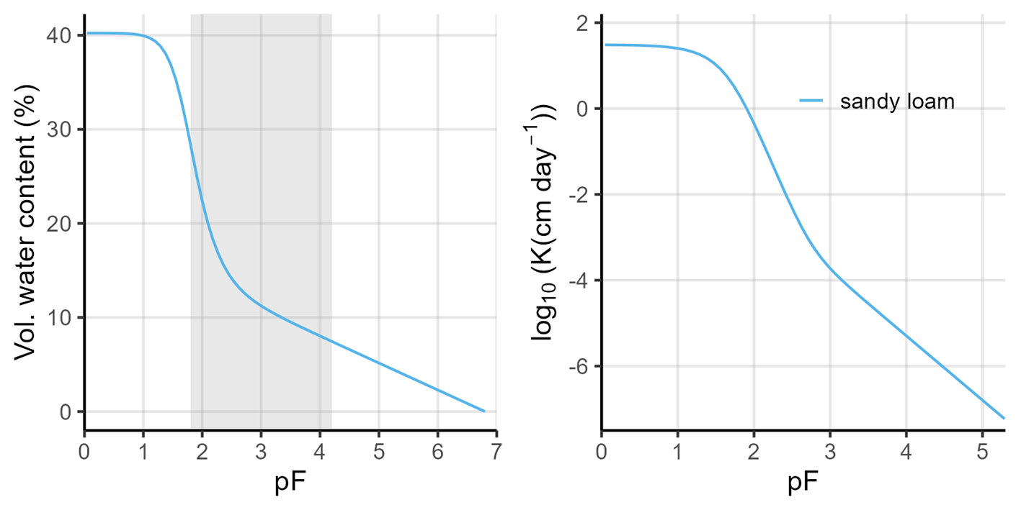
Figure S2.1: Water retention curve (left) and hydraulic conductivity curve (right) of a sandy loam as representative texture class according to Lange (2023). The grey shaded area marks the plant-available water content (between pF 1.8 and 4.2).

Climatic Conditions and Irrigation Regime
Simulations adopted a humid and semi-arid climate scenario corresponding to the weather dataset of Hamburg (Germany) and Thiva (Greece) provided in the FOCUS groundwater scenarios (FOCUS, 2021). Demand-based irrigation with treated reclaimed water (RW) was simulated using a user-defined irrigation schedule that maintained soil moisture near field capacity. In more detail, irrigation was triggered dynamically whenever the plant root zone experienced water stress, defined as the soil water pressure falling below a threshold of –330 hPa which equals field capacity within the effective root depth. The effective rooting depth was dynamically adjusted during the simulation to reflect crop development stages, reaching a maximum of 60 cm for winter wheat and 30 cm for phacelia.
This irrigation regime ensures a realistic temporal pattern of RW application while avoiding artifacts from fixed or excessive irrigation volumes. It also reflects hydrological conditions typical for RW reuse systems in under humid climate.

2 Correction of biodegradation rates and overview of reaction-parameters used in Hydrus-1D field-scale simulations
Biodegradation in soils is governed not only by the chemical characteristics of organic micropollutants (OMP), but also by environmental conditions such as temperature, moisture, and soil depth (e.g., FOCUS, 2021; Naylor et al., 2022; Rietra et al., 2024). To improve the transferability of lab-derived degradation parameters to field-scale transport modeling, a set of empirically based correction factors were applied. This approach follows recommendations by FOCUS (2021) and similar studies (e.g., Campan et al., 2023), and ensures that first-order rate constants used in the Hydrus-1D simulations better reflect realistic field conditions. In the following subsections the individual correction approaches are described in detail.

Soil Depth Correction
Microbial activity generally declines with increasing soil depth, driven by factors such as decreasing organic matter content, nutrient availability, and oxygen concentration (Veeh et al., 1996; Naylor et al., 2022; Rietra et al., 2024). Accordingly, degradation rates were scaled using depth-dependent correction factors adopted from the FOCUS groundwater scenarios (FOCUS, 2021), which are based on empirical observations. These factors allow extrapolation of topsoil degradation parameters to subsoil layers:
- 0 – 30 cm: $f_{depth}$ = 1.0
- 30 – 60 cm: $f_{depth }$= 0.5
- 60 – 100 cm: $f_{depth}$= 0.3
- > 100 cm: $f_{depth}$= 0.0

Temperature Correction
Soil temperature strongly affects microbial degradation by altering enzyme activity and microbial metabolism. Following FOCUS (2021), temperature correction was applied using the Arrhenius-based Q₁₀ approach:
$$f_{temp}=Q^{\frac{T-T_{0}}{10}}$$ | (S1)
where, $f_{temp}$ is the temperature correction factor (-), $Q$ is the factor for rate increase given a temperature rise of 10 °C, $T_{0}$ is the reference temperature of the experimental condition (°C), and $T$ is the actual soil temperature (°C). The recommended default value for the $Q$ value of 2.58 (FOCUS, 2021) was adopted. The applied correction was than based on the deviation of the experimental temperature (25 °C) from the site-specific annual mean temperature of 12.7 °C derived from the german weather station located near Michendorf, south of Potsdam (station ID: 3987), which represents the closest station to the soil sampling site.

Soil Moisture Correction
Microbial degradation in soils is strongly controlled by water availability, which affects microbial metabolism, substrate diffusion, and enzyme activity. To account for these effects in Hydrus-1D simulations, a correction factor was applied based on the moisture-dependent model proposed by Walker (1978) and Walker & Barnes (1981), as recommended in the FOCUS groundwater scenarios (FOCUS, 2021):
$$f_{moist}= {\left(\frac{θ}{θ_{0}}\right)}^{f_{w}}$$ | (S2)
where, $f_{moist}$ is the soil moisture correction factor for the biodegradation, $θ$ is the volumetric soil moisture at field (vol. %), $θ_{0}$ is the moisture during the degradation experiment (vol. %), and $f_{w}$ is the empirical exponent describing the moisture dependency of microbial activity (-). In this study, $θ$ was set to 13.8 vol. %, corresponding to half of field capacity, to represent typical average moisture conditions for the field site. For the laboratory batch experiments,$θ_{0}$​ was approximated as the total porosity of the soil (40.2 vol. %), since the experiments were conducted under oversaturated conditions. The empirical exponent $f_{w}$was set to 0.7, consistent with default values recommended by FOCUS (2021).

Final correction of biodegradation and parameters used in Hydrus-1D simulations
These correction factors were combined multiplicatively to obtain field-adjusted degradation rates $k_{field}$ for each soil layer in the model:
$$k_{field}= k_{lab}* f_{depth}* f_{temp}* f_{moist}$$ | (S3)
The resulting depth-specific rate constants were used in Hydrus-1D simulations to more realistically represent degradation potential throughout the soil profile under site-specific RW irrigation conditions. All final values for kinetic and sorption parameters used in the simulations are summarized in Table S1.

Table S1: Reaction parameters used in Hydrus-1D simulation to assess relative importance of sorption kinetics and microbial adaption field-scale transport of investigated OMP. Sorption was restricted to occur in first soil horizon (0 – 30 cm depth). For assessment of sorption kinetics effect, results were compared against a simulation using equilibrium solute model, in which $f$ = 1 and $α$ = 0.
 | OMP | Material distribution depth | Sorption Isotherm |  |  | Sorption kinetics |  | Scaled microbial degrdation
 |  |  | $$k_{d }$$ | $$k_{f}$$ | $$n$$ | $$α$$ | $$f$$ | $$k$$
 |  | cm | L kg⁻¹ | µg^{1-n} L^{n} kg⁻¹ | - | d⁻¹ | - | d⁻¹
Sorption kinetics | ATA | 0 – 30 | - | 3.23 | 0.926 | 0.962 | 0.659 | 0.0180
Sorption kinetics |  | 30 – 60 | - | 0 | 1 | 100* | 0.999* | 0.0090
Sorption kinetics |  | 60 – 100 | - | 0 | 1 | 100* | 0.999* | 0.0054
Sorption kinetics |  | 100 – 200 | - | 0 | 1 | 100* | 0.999* | 0
Sorption kinetics | CBZ | 0 – 30 |  | 3.85 | 0.942 | 1.296 | 0.627 | 0.0238
Sorption kinetics |  | 30 – 60 | - | 0 | 1 | 100* | 0.999* | 0.0119
Sorption kinetics |  | 60 – 100 | - | 0 | 1 | 100* | 0.999* | 0.0071
Sorption kinetics |  | 100 – 200 | - | 0 | 1 | 100* | 0.999* | 0
Sorption kinetics | DCF | 0 – 30 | 2.266 | - | - | 0.107 | 0.292 | 0.371
Sorption kinetics |  | 30 – 60 | 0 | - | - | 100* | 0.999* | 0.186
Sorption kinetics |  | 60 – 100 | 0 | - | - | 100* | 0.999* | 0.112
Sorption kinetics |  | 100 – 200 | 0 | - | - | 100* | 0.999* | 0
Sorption kinetics | SMX | 0 – 30 | 0.987 | - | - | 1.602 | 0.424 | 0.102
Sorption kinetics |  | 30 – 60 | 0 | - | - | 100* | 0.999* | 0.051
Sorption kinetics |  | 60 – 100 | 0 | - | - | 100* | 0.999* | 0.030
Sorption kinetics |  | 100 – 200 | 0 | - | - | 100* | 0.999* | 0
Microbial adaption | ACE | 0 – 30 | 0 | - | - | - | 1 | 0.501
Microbial adaption |  | 30 – 60 | 0 | - | - | - | 1 | 0.251
Microbial adaption |  | 60 – 100 | 0 | - | - | - | 1 | 0.150
Microbial adaption |  | 100 – 200 | 0 | - | - | - | 1 | 0
Microbial adaption | SAC | 0 – 30 | 0 | - | - | - | 1 | 0.261
Microbial adaption |  | 30 – 60 | 0 | - | - | - | 1 | 0.131
Microbial adaption |  | 60 – 100 | 0 | - | - | - | 1 | 0.078
Microbial adaption |  | 100 – 200 | 0 | - | - | - | 1 | 0
Microbial adaption | VSA | 0 – 30 | 0 | - | - | - | 1 | 0.070
Microbial adaption |  | 30 – 60 | 0 | - | - | - | 1 | 0.035
Microbial adaption |  | 60 – 100 | 0 | - | - | - | 1 | 0.021
Microbial adaption |  | 100 – 200 | 0 | - | - | - | 1 | 0
*For two-site kinetic models, the parameter$α$ and $f$ where set to 100 d⁻¹ and 0.999, respectively for lower soil materials, however, since no sorption (K_{d} = 0 L kg⁻¹) in considered in theses soil material, it has no effect anyways.

SI for Results & Discussion section

1. Discussion of DCF experimental uncertainties and comparison of sorption kinetics with literature
For DCF, the modeling revealed considerable uncertainty in the estimated sorption kinetics, primarily due to inconsistencies between the isotherm and kinetic batch experiments. The linear sorption isotherm yielded a K_{d} of 2.27 L kg⁻¹, suggesting moderate sorption strength. However, the concentration observed in the abiotic kinetic experiment after 48 hours was roughly 17 µg L⁻¹, which is notably higher than the ~12 µg L⁻¹ expected if equilibrium were achieved based on the isotherm-derived K_{d} (see “EQ Henry*” in Figure 2). Thus, the grey dashed-dotted line in sorption kinetics sub-plots of Figure 2 labeled “EQ Henry*” represents an apparent equilibrium model with only instantaneous sorption, calculated by the linear K_{d} obtained in isotherm experiment. This line indicates whether the sorption equilibrium between the isotherm and sorption kinetics experiment is coherent. This mismatch implies that either equilibrium was not reached within 48 hours in the kinetic setup or the sorption behavior differed between the experiments. Accordingly, the fitted flexible two-site kinetic model for DCF yielded a slow sorption rate constant for the kinetic limited S2-sites (α = 0.0045 hours⁻¹), which does probably not reflect the real sorption dynamics.
Notably, the K_{d} value obtained in this study aligns well with previous isotherm experiments conducted on the same soil (Thalmann et al., 2025a), suggesting that the 48-hour equilibration time in the isotherm batch was likely sufficient. Thus, sorption appears unrealistic slow, as also indicated by other sorption studies of DCF in which equilibrium was reached within 24 hours (e.g., Prakathi et al. 2020; Revitt et al., 2015). Since pH and EC values were similar between both experiments at 48 hours (see Section S1.2), these cannot account for the observed discrepancy. A key source for this mismatch may be the initial concentration (Cini) used for the kinetic modeling. Due to analytical issues in the abiotic batch, this value was not directly measured and was instead inferred from control samples (indicated as “Cini of DCF*” in Figure 2), potentially introducing systematic error into the model fitting. Summarizing, it remains unclear whether the observed sorption discrepancy for DCF results from (i) incomplete equilibration in the kinetic batch, (ii) genuinely slow sorption to kinetic sites, or (iii) underestimation of Cini in the abiotic batch. Despite these uncertainties, the fitted slow kinetic sorption for DCF was retained and later used as an extreme-case scenario in subsequent field-scale simulations.

2. Non-reactive OMP
DZA, TFMSA, and PRI exhibited no or not quantifiably low reaction behavior in all experiments. In the isotherm experiments, these OMP showed no measurable sorption to soil, with distribution coefficients (K_{d}) consistently below 0.2 L kg⁻¹. This threshold represents the minimum quantifiable sorption, considering a 10% relative analytical error and the applied soil-to-solution ratio of 1:2.
In the kinetic experiments, the mass recovery of DZA and TFMSA remained nearly identical to the initial mass (m₀) throughout the entire experimental duration (~27 days, including both OMP spikes) and aligned with control samples, as shown in Figure S1. These findings indicate that under the given conditions, DZA and TFMSA were essentially non-reactive in the tested soil. In isotherm experiments with the same topsoil, DZA showed neglectable sorption under various solution properties (Thalmann et al., 2025a). Moreover, DZA and TFMSA displayed conservative, tracer-like transport in a three-year lysimeter study from the same location and irrigated with RW from the same WWTP (Thalmann et al., 2025b). Furthermore, other lab-scale column experiments (Bertelkamp, 2014; Zeeshan et al., 2023) and field studies (Ternes et al., 2007) have reported high persistence and mobility of DZA in sediments. For TFMSA data on the environmental fate in soil is generally scares.
For PRI, a slight concentration decrease was observed following the first spike event in the main samples but was absent in control samples, suggesting a minimal sorption affinity (Figure 1). This is consistent with its apparent K_{d} value (0.19 L kg⁻¹), which falls just below the quantification threshold. Thus, a small fraction of PRI may have been sorbed to the soil, as similarly reported in the previously mentioned lysimeter studies in which PRI was retarded to some degree (Thalmann et al., 2025b). A negligible retardation of PRI was also observed in saturated column experiments conducted with river sediments (0.23 % C_{org}) across various pH conditions (Schaffer et al., 2012). Additionally, PRI biodegradation was found to be insignificant in sandy soils (Yu et al., 2009), further supporting its persistence in soil environments
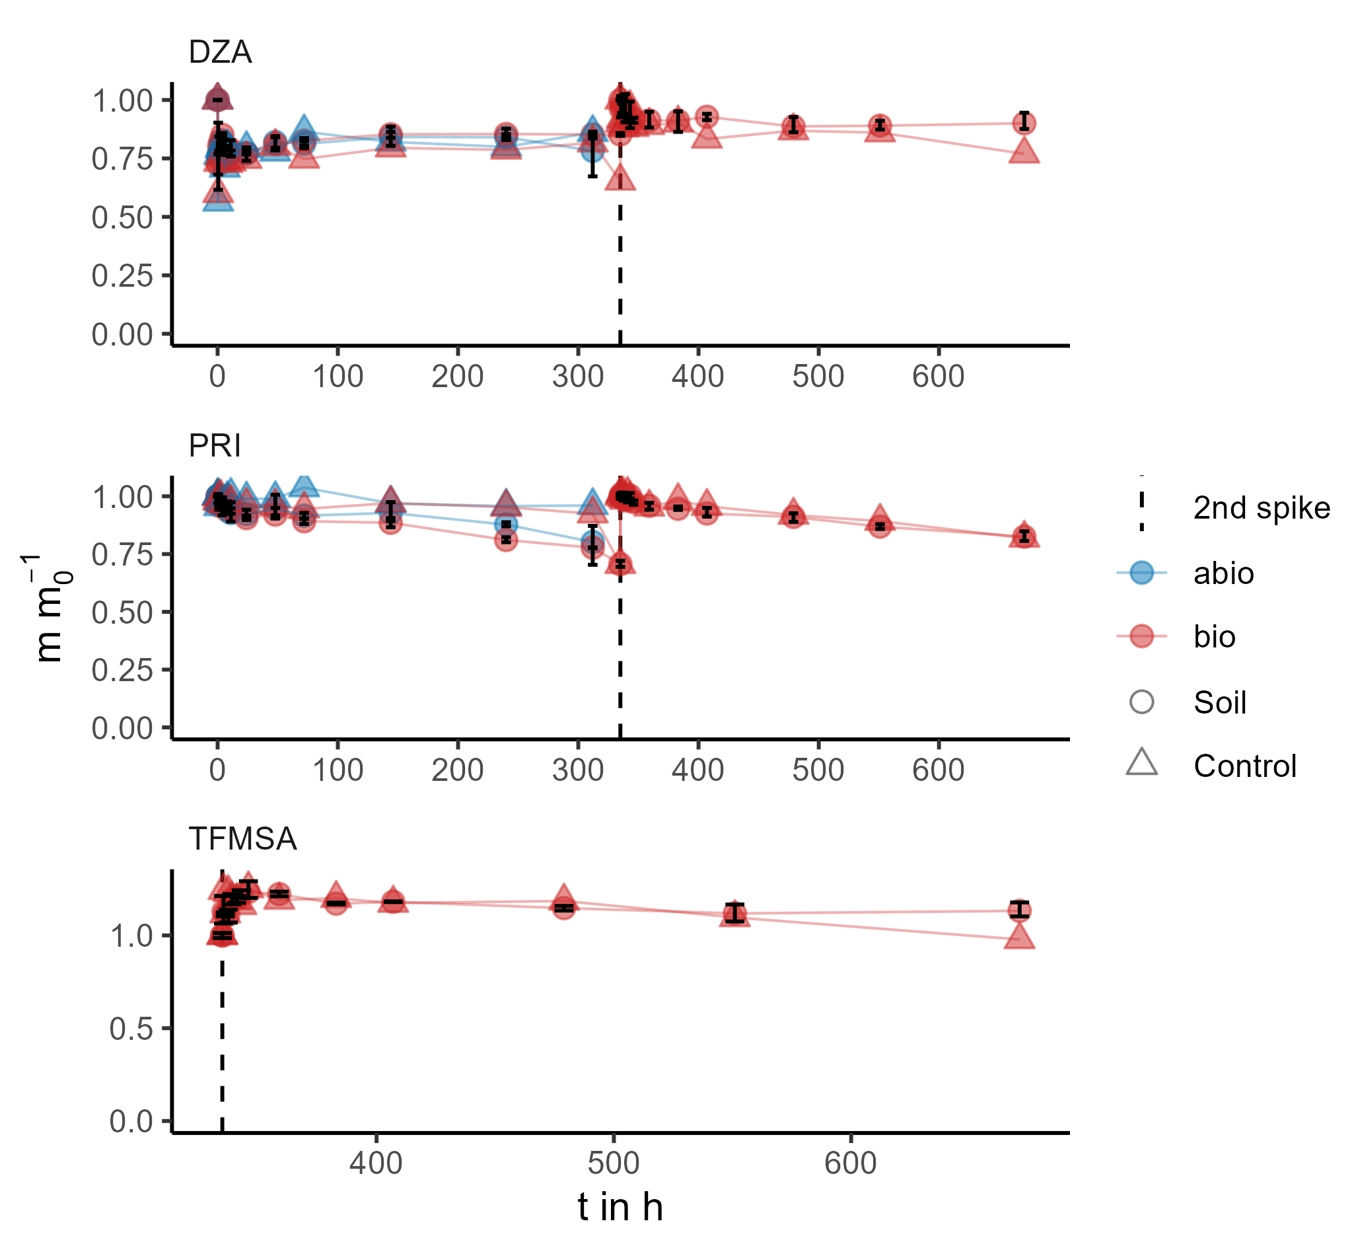
Figure S3.1: Relative mass (m m₀⁻¹) of DZA, PRI, and TFMSA in kinetic experiments under both abiotic (0.2 g L⁻¹ NaN₃) and biotic conditions. For TFMSA, only results following the second spike were evaluated.

References
Bertelkamp, C., Reungoat, J., Cornelissen, E. R., Singhal, N., Reynisson, J., Cabo, A. J., . . . Verliefde, A. R. (April 2014). Sorption and biodegradation of organic micropollutants during river bank filtration: A laboratory column study. Water Research, 52, 231–241. doi:10.1016/j.watres.2013.10.068
Campan, P., Samouelian, A., & Voltz, M. (2023). Evaluation of temperature corrections for pesticide half-lives in tropical and temperate soils. Environmental Science and Pollution Research, 30, 21468–21480. doi:10.1007/s11356-022-23566-9
Chefetz, B., Stimler, K., Shechter, M., & Drori, Y. (2006). Interactions of sodium azide with triazine herbicides: Effect on sorption to soils. Chemosphere, 65, 352–357. doi:10.1016/j.chemosphere.2006.03.006
Feddes, R. A. (1982). Simulation of field water use and crop yield. In F. W. T. Penning de Vries, & H. H. van Laar (Eds.), Simulation of plant growth and crop production (pp. 194-209). (Simulation monographs). Pudoc. https://edepot.wur.nl/172222
Feifel, M., Durner, W., Hohenbrink, T. L., & Peters, A. (December 2024). Effects of improved water retention by increased soil organic matter on the water balance of arable soils: A numerical analysis. Vadose Zone Journal, 23. doi:10.1002/vzj2.20302
Flores-Céspedes, F., Fernández-Pérez, M., Villafranca-Sánchez, M., & González-Pradas, E. (August 2006). Cosorption study of organic pollutants and dissolved organic matter in a soil. Environmental Pollution, 142, 449–456. doi:10.1016/j.envpol.2005.10.019
FOCUS. (2021). Generic Guidance for Tier 1 FOCUS Ground Water Assessments. Version 2.3. Generic Guidance for Tier 1 FOCUS Ground Water Assessments. Version 2.3. Retrieved from https://esdac.jrc.ec.europa.eu/public_path/projects_data/focus/gw/docs/Generic_guidance_FOCUS_GW_V2-3final.pdf
Hohenbrink, T. L., Jackisch, C., Durner, W., Germer, K., Iden, S. C., Kreiselmeier, J., . . . Peters, A. (March 2023). Soil water retention and hydraulic conductivity measured in a wide saturation range. doi:10.5194/essd-2023-74
Jarvis, N. J. (1989). A simple empirical model of root water uptake. Journal of Hydrology, 107, 57–72. doi:10.1016/0022-1694(89)90050-4
Lange, A. (2023). Classification of the texture triangle by soil hydrological criteria. Master’s thesis, Technische Universität Braunschweig, Institute of Geoecology, Soil Science and Soil Physics Division.
Lees, K., Fitzsimons, M., Snape, J., Tappin, A., & Comber, S. (2018). Soil sterilisation methods for use in OECD 106: How effective are they? Chemosphere, 209, 61–67. doi:10.1016/j.chemosphere.2018.06.073
Naylor, D., McClure, R., & Jansson, J. (February 2022). Trends in Microbial Community Composition and Function by Soil Depth. Microorganisms, 10, 540. doi:10.3390/microorganisms10030540
Peters, A., Durner, W., & Iden, S. (May 2024). The PDI model system for parameterizing soil hydraulic properties. Vadose Zone Journal. doi:10.1002/vzj2.20338
Prakathi, J., Mahanty, B., & Lhamo, P. (2020). Adsorption, Bioavailability and Microbial Toxicity of Diclofenac in Agricultural Soil. Bulletin of Environmental Contamination and Toxicology, 105, 490–495. doi:10.1007/s00128-020-02955-1
Revitt, D. M., Balogh, T., & Jones, H. (2015). Sorption behaviours and transport potentials for selected pharmaceuticals and triclosan in two sterilised soils. Journal of Soils and Sediments, 15, 594–606. doi:10.1007/s11368-014-1025-y
Rietra, R. P., Berendsen, B. J., Mi-Gegotek, Y., Römkens, P. F., & Pustjens, A. M. (January 2024). Prediction of the mobility and persistence of eight antibiotics based on soil characteristics. Heliyon, 10, e23718. doi:10.1016/j.heliyon.2023.e23718
Schaffer, M., Boxberger, N., Börnick, H., Licha, T., & Worch, E. (2012). Sorption influenced transport of ionizable pharmaceuticals onto a natural sandy aquifer sediment at different pH. Chemosphere, 87, 513–520. doi:10.1016/j.chemosphere.2011.12.053
Šimůnek, J., Šejna, M., Saito, H., Sakai, M., & & van Genuchten, M. T. (2013). The hydrus-1D software package for simulating the movement of water, heat, and multiple solutes in variably saturated media (version 4.17) [software]. https://www.pc-progress.com. The hydrus-1D software package for simulating the movement of water, heat, and multiple solutes in variably saturated media (version 4.17) [software]. https://www.pc-progress.com. Von https://www.pc-progress.com abgerufen
Süßmuth, R., Shrestha, P., Andrea Diaz Navarrete, C., Wege, F.-F., Achten, C., & Hennecke, D. (June 2024). Impact of different sterilisation techniques on sorption and NER formation of test chemicals in soil. Chemosphere, 357, 141915. doi:10.1016/j.chemosphere.2024.141915
Ternes, T. A., Bonerz, M., Herrmann, N., Teiser, B., & Andersen, H. R. (2007). Irrigation of treated wastewater in Braunschweig, Germany: An option to remove pharmaceuticals and musk fragrances. 66, 894–904. doi:10.1016/j.chemosphere.2006.06.035
Thalmann, M., Neubert, L., Klitzke, S., Ruhl, A. S., & Peters, A. (2025a). Sorption of Organic Micropollutants to an Agricultural Soil: Effect of Ionic Strength, Cation Valence and pH. Water, Air, & Soil Pollution, 236. doi:10.1007/s11270-025-07885-4
Thalmann, M., Klitzke, S., Ruhl, A. S., & Peters, A. (2025b). Leaching of organic micropollutants in an arable sandy soil irrigated with reclaimed water: A lysimeter study. Water Reuse. doi:10.2166/wrd.2025.014
Thalmann, M., Hohenbrink, T. L., Klitzke, S., Ruhl, A. S., & Peters, A (under review). User-Friendly Tool for the Assessment of Groundwater Contamination Risks by Long-Term Irrigation with Reclaimed Water. Submitted to Journal of Contaminant Hydrology (25.06.2025). Preprint available at http://dx.doi.org/10.2139/ssrn.5231271
Vanderborght, J., & Vereecken, H. (February 2007). Review of Dispersivities for Transport Modeling in Soils. Vadose Zone Journal, 6, 29–52. doi:10.2136/vzj2006.0096
Veeh, R. H., Inskeep, W. P., & Camper, A. K. (January 1996). Soil Depth and Temperature Effects on Microbial Degradation of 2,4‐D. Journal of Environmental Quality, 25, 5–12. doi:10.2134/jeq1996.00472425002500010002x
WALKER, A. (October 1978). Simulation of the persistence of eight soil‐applied herhicides. Weed Research, 18, 305–313. doi:10.1111/j.1365-3180.1978.tb01165.x
Walker, A., & Barnes, A. (April 1981). Simulation of herbicide persistence in soil; a revised computer model. Pesticide Science, 12, 123–132. doi:10.1002/ps.2780120204
Yu, L., Fink, G., Wintgens, T., Melin, T., & Ternes, T. A. (2009). Sorption behavior of potential organic wastewater indicators with soils. Water Research, 43, 951–960. doi:10.1016/j.watres.2008.11.032
Zeeshan, M., Schumann, P., Pabst, S., & Ruhl, A. S. (May 2023). Transformation of potentially persistent and mobile organic micropollutants in column experiments. Heliyon, 9, e15822. doi:10.1016/j.heliyon.2023.e15822

