Supplementary Material
Removal of bacteriophages MS2 and ΦX174 in biotic iron and manganese filters and in ultrafiltration of iron and manganese containing backwash water

A. Steuer^{1,2}, C. Kast³, D. Mahringer¹, C. Förster⁴, M. Ernst^{3,5}, A. S. Ruhl^{1,2}
¹ Section II 3.3, German Environment Agency (UBA), Schichauweg 58, 12307 Berlin, Germany
² Water Treatment, Technische Universität Berlin, KF 4, Straße des 17. Juni 135, 10623 Berlin, Germany
³ DVGW Research Center, TU Hamburg, Am Schwarzenberg-Campus 3 (E), 21073 Hamburg, Germany
⁴ Section II 3.5, German Environment Agency (UBA), Heinrich-Heine-Str. 12, 08645 Bad Elster, Germany
⁵ Institute of Water Resources and Water Supply, TU Hamburg, Am Schwarzenberg-Campus 3 (E), 21073 Hamburg, Germany
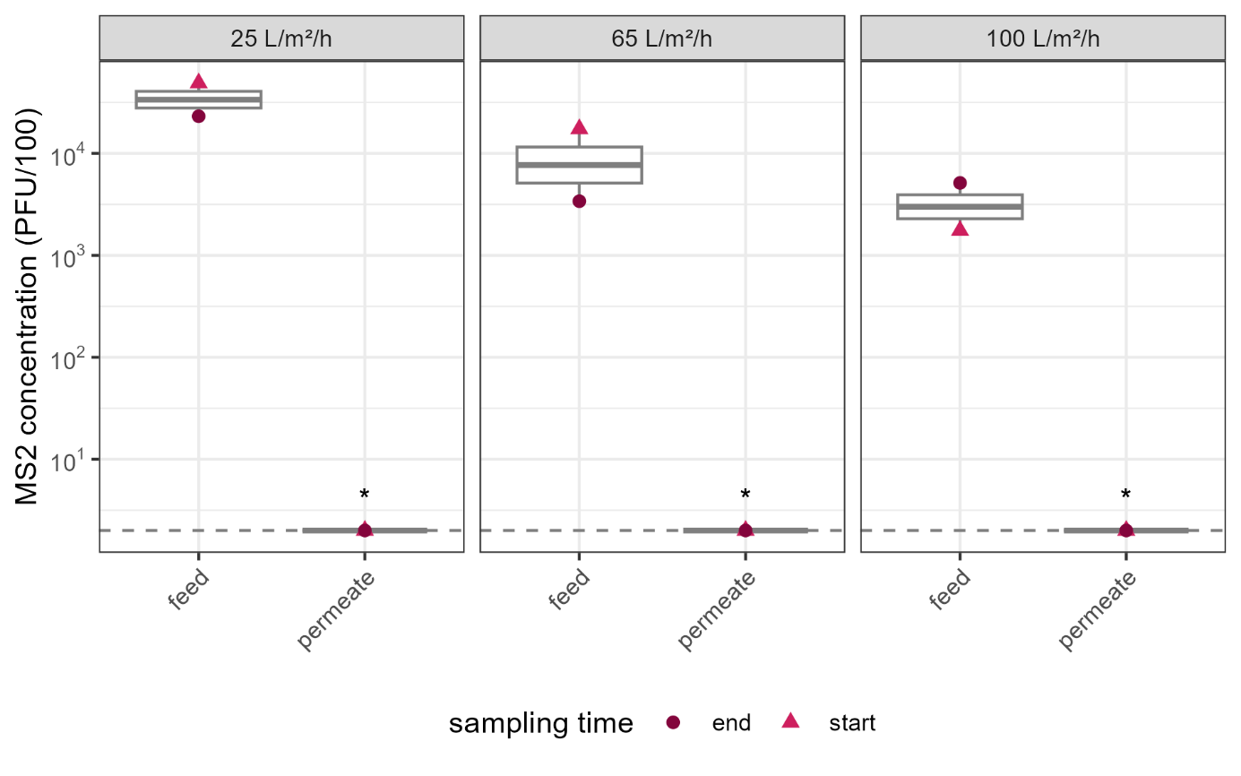
Figure SI1: Concentration of MS2 phage in feed and permeate samples of Fe-FSW during UF at different membrane fluxes. Dashed grey line indicates the LOQ (2 PFU/100 mL) and an asterisk indicates samples were below LOQ and set to LOQ for calculations and display.

